Metrics are not computable for img016001.jpg with bg_tresh: 0.75

ID 0: (1677, 710)

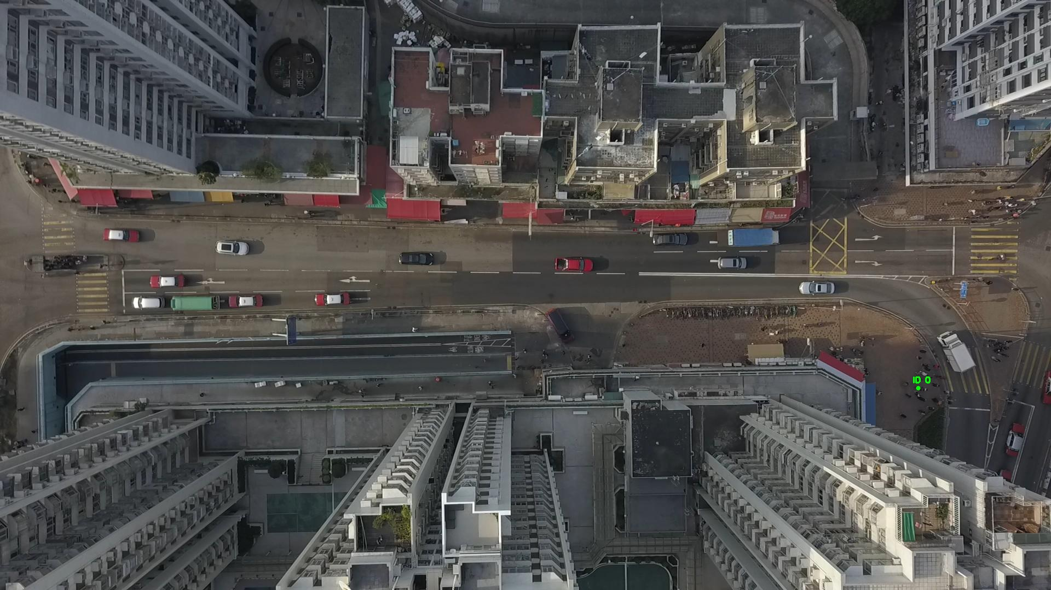

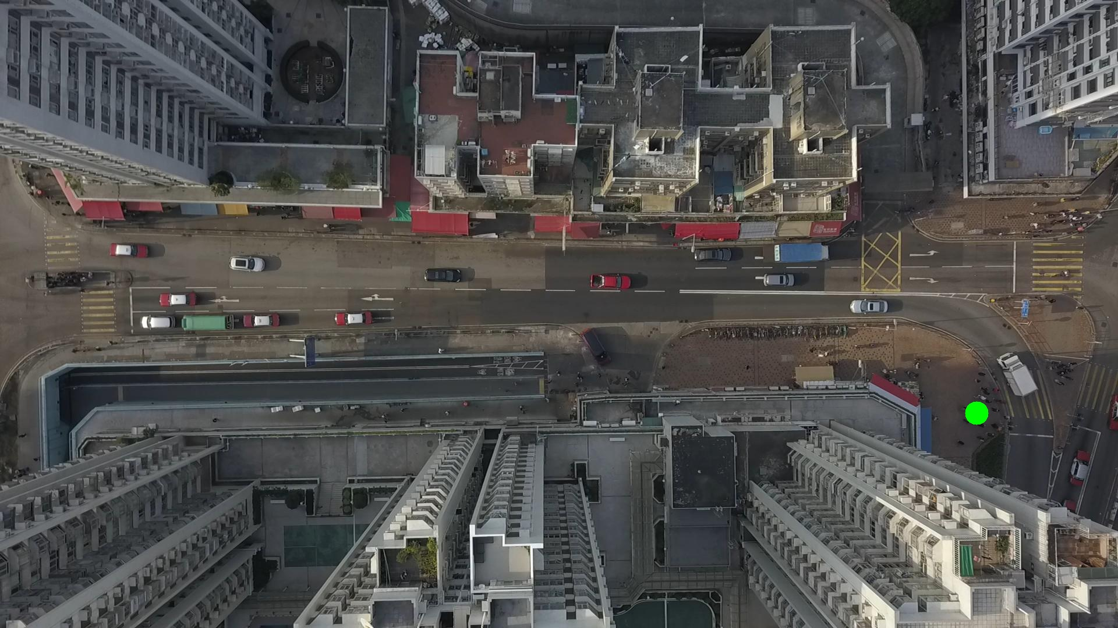

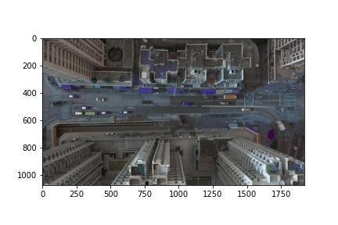

Metrics are not computable for img016002.jpg with bg_tresh: 0.75

ID 0: (1676, 714)

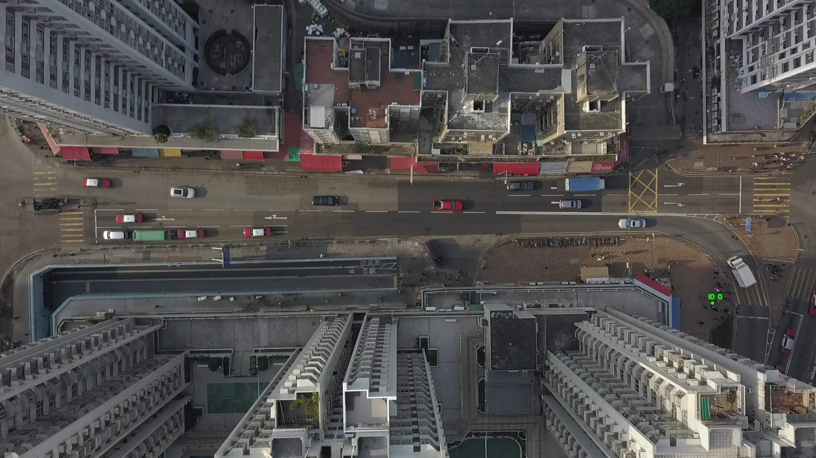

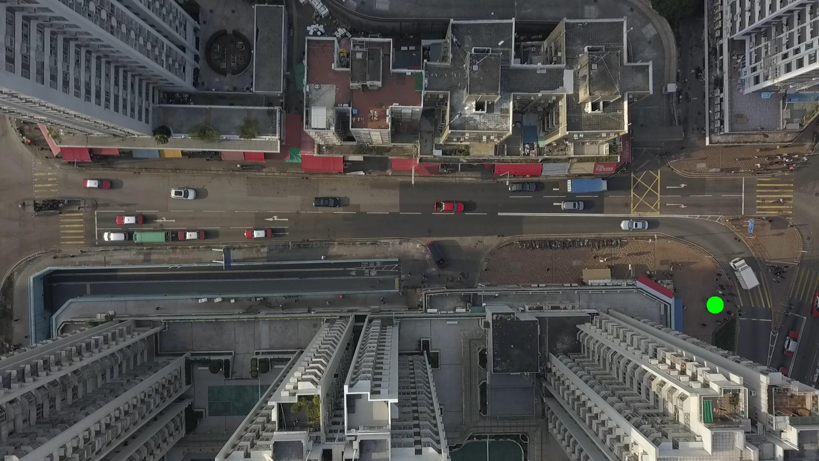

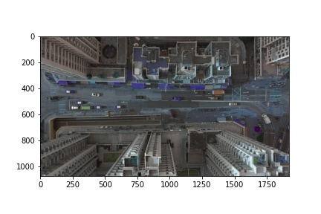

Metrics are not computable for img016003.jpg with bg_tresh: 0.75

ID 0: (1680, 694)

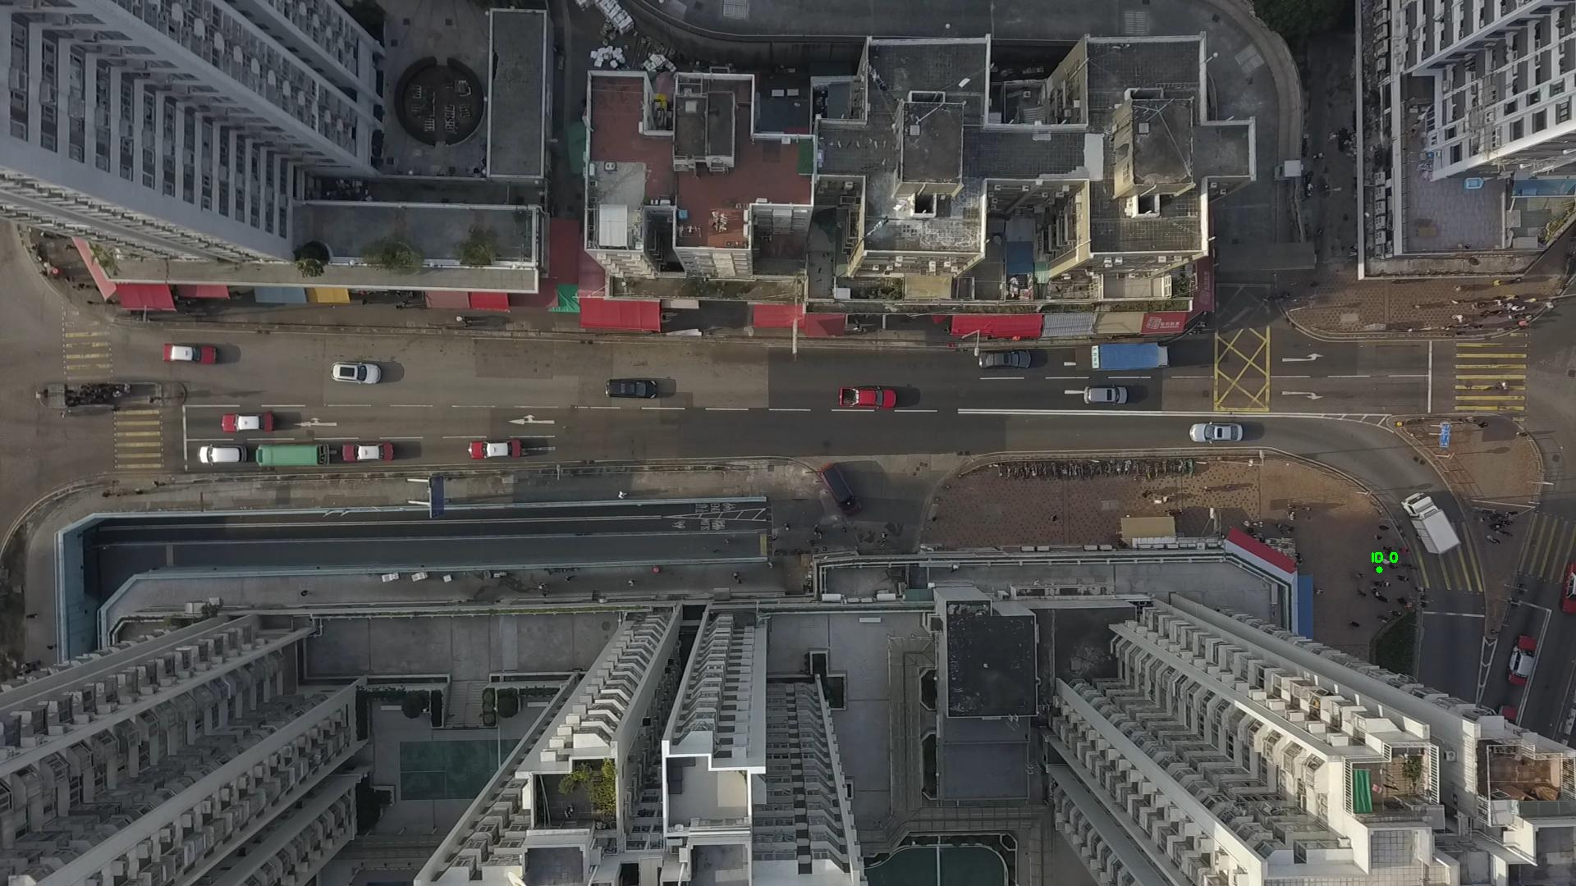

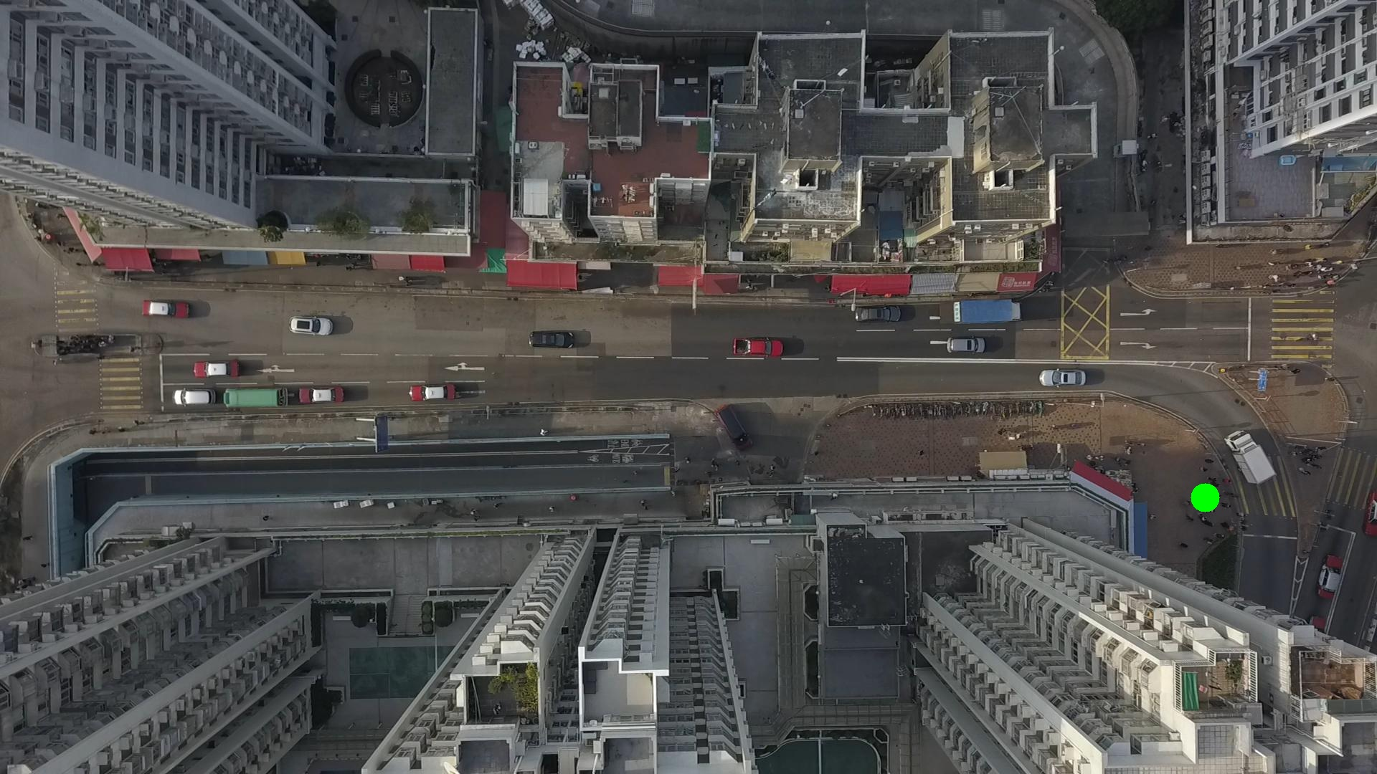

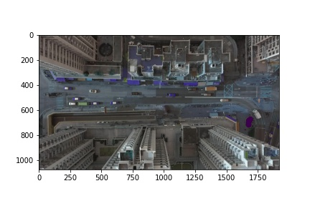

Metrics are not computable for img016004.jpg with bg_tresh: 0.75

ID 0: (1677, 701)

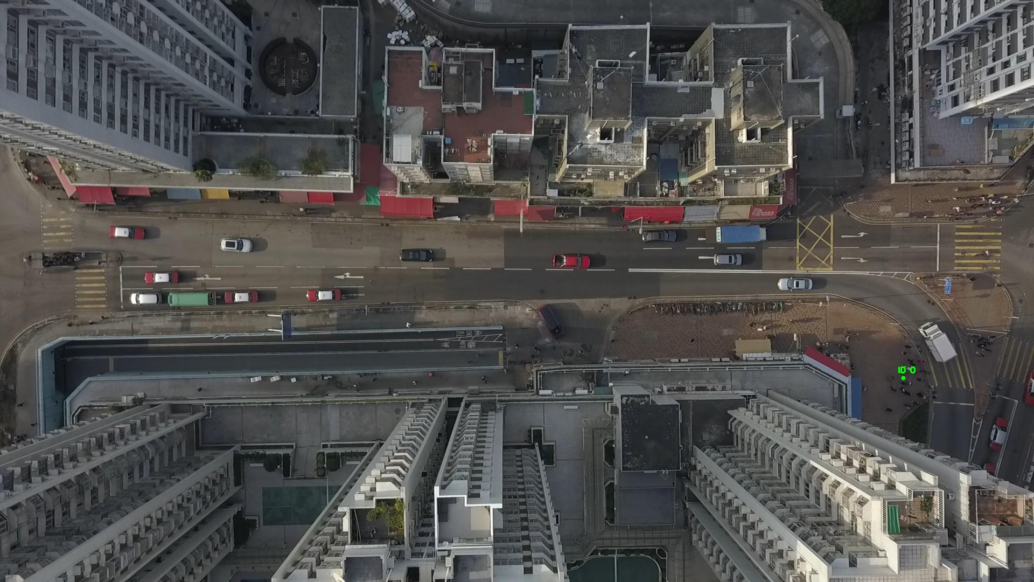

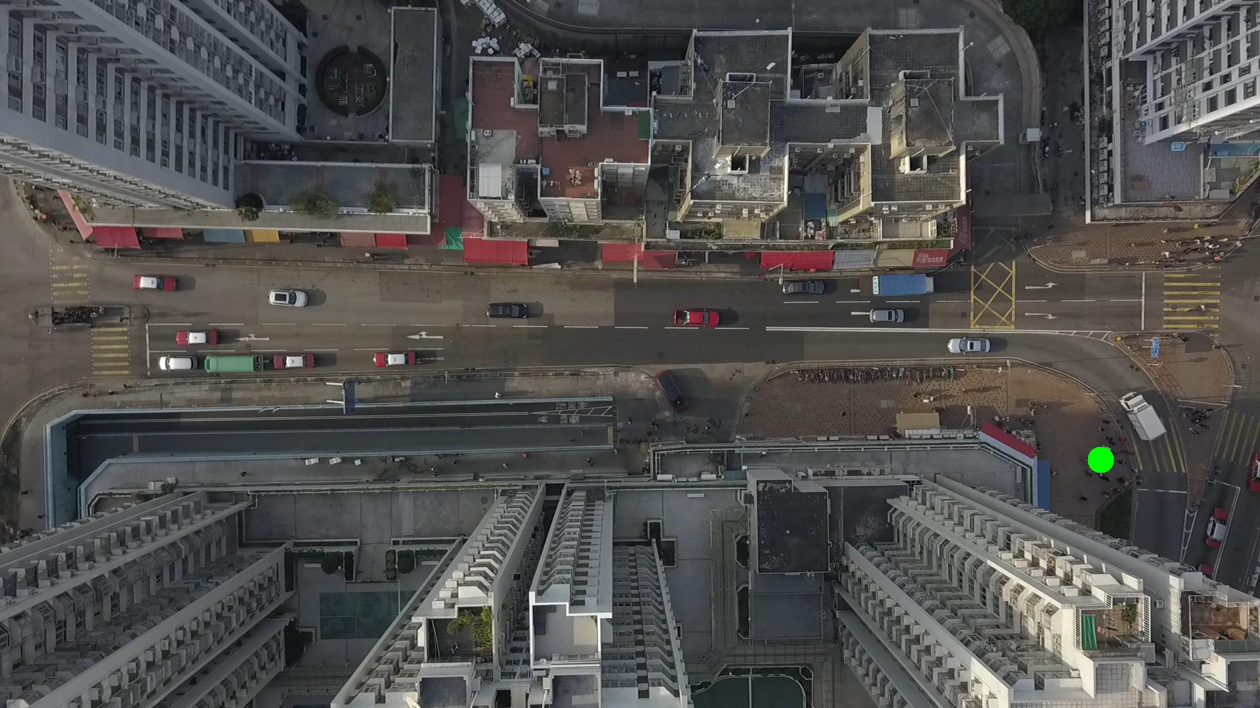

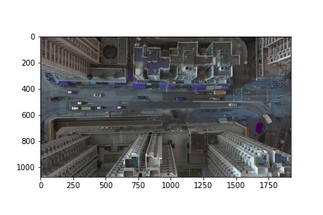

Silhouette metric for img016005.jpg is: 0.9771452514312633

Davies Bouldin metric for img016005.jpg is: 0.011206549750231158

Calinski Harabasz metric for img016005.jpg is: 7505.191837116344

ID 0: (1676, 703)

ID 1: (433, 1058)

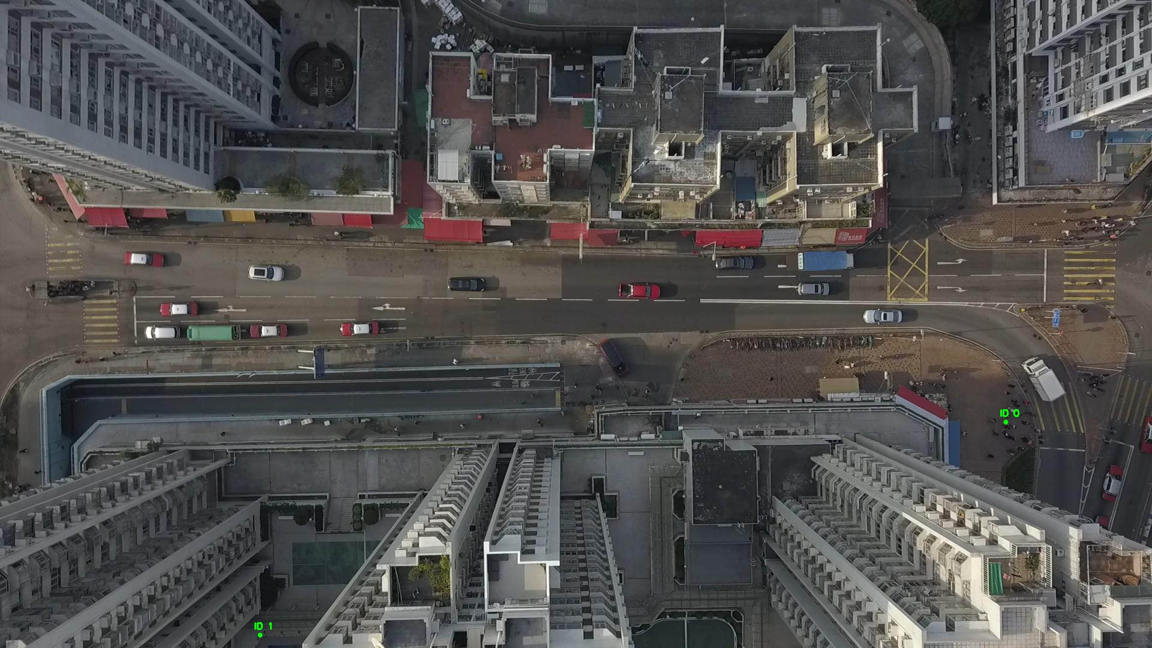

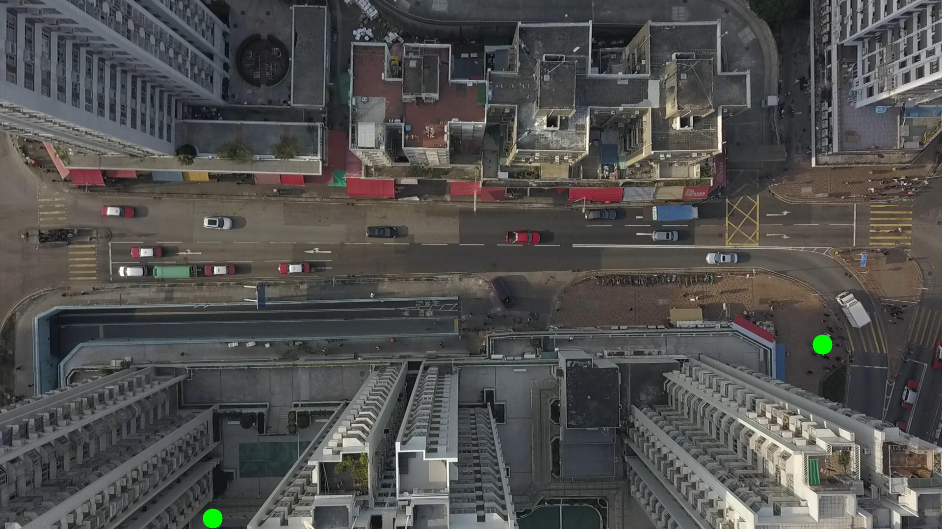

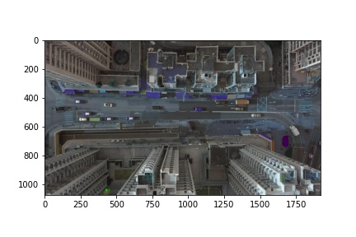

Silhouette metric for img016006.jpg is: 0.9901571915864265

Davies Bouldin metric for img016006.jpg is: 0.01319354554031692

Calinski Harabasz metric for img016006.jpg is: 297086.326305704

ID 0: (1676, 706)

ID 1: (433, 1059)

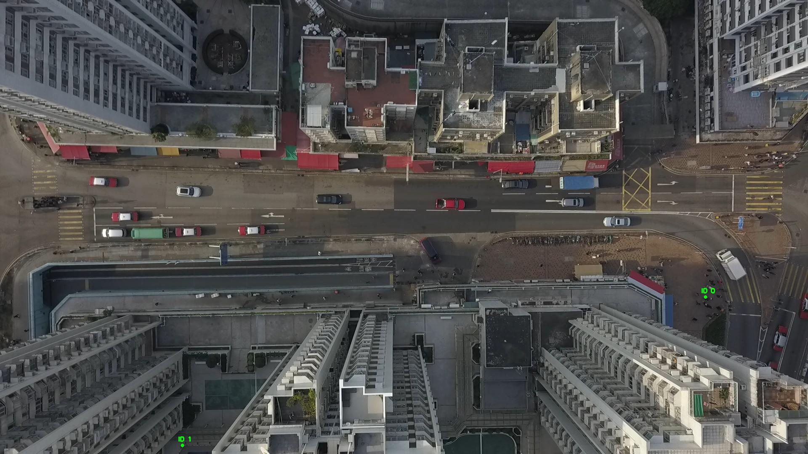

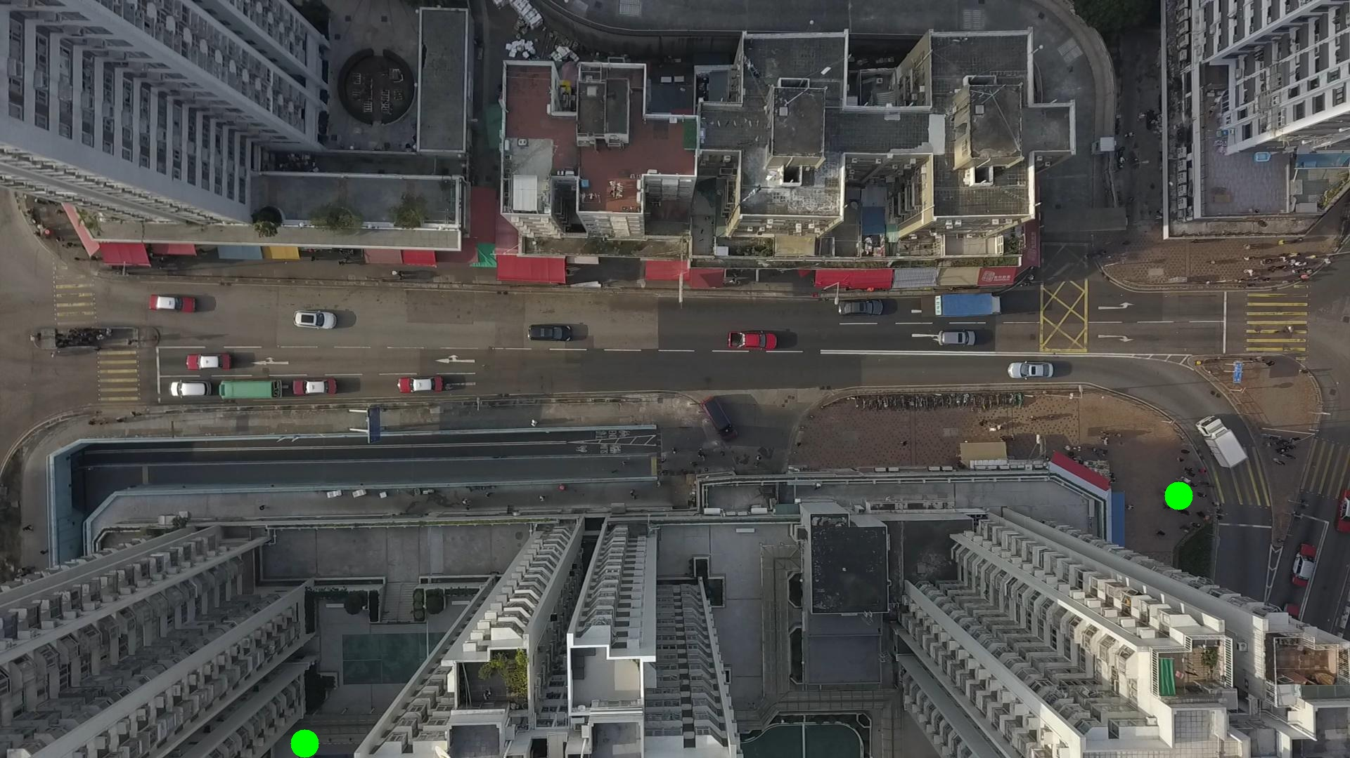

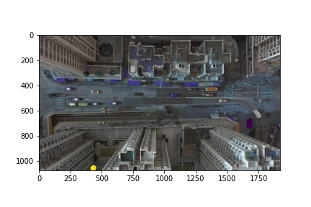

Silhouette metric for img016007.jpg is: 0.9028205948230001

Davies Bouldin metric for img016007.jpg is: 0.0984243812469799

Calinski Harabasz metric for img016007.jpg is: 792.0543808048387

ID 0: (1676, 701)

ID 1: (433, 1059)

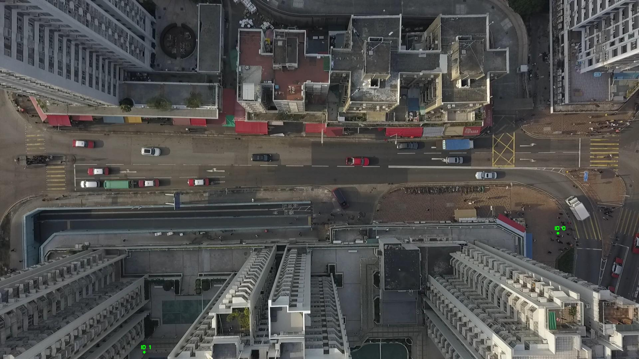

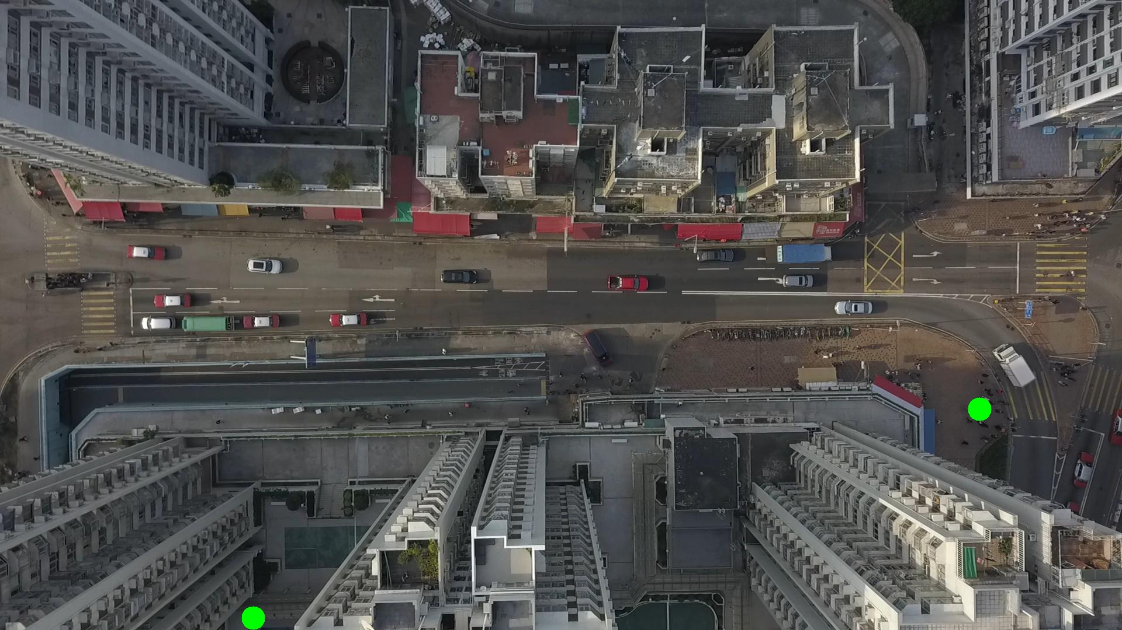

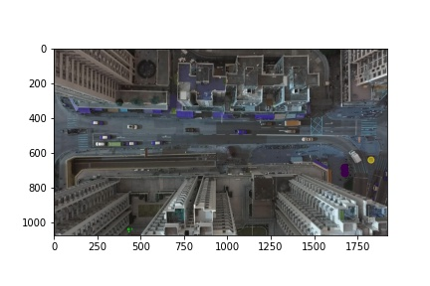

Silhouette metric for img016008.jpg is: 0.8975386776825689

Davies Bouldin metric for img016008.jpg is: 0.08872857347937864

Calinski Harabasz metric for img016008.jpg is: 1300.6450541189258

ID 0: (1683, 683)

ID 1: (433, 1059)

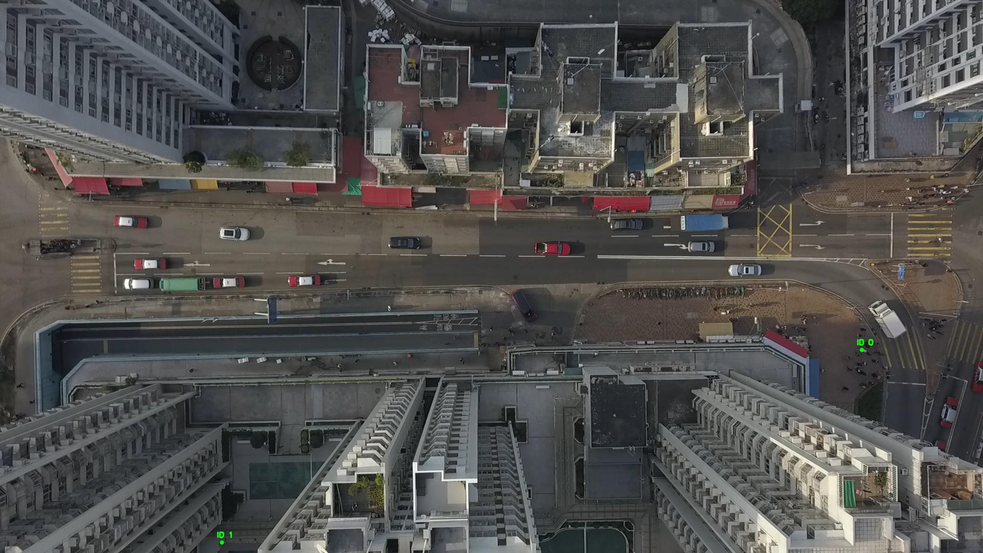

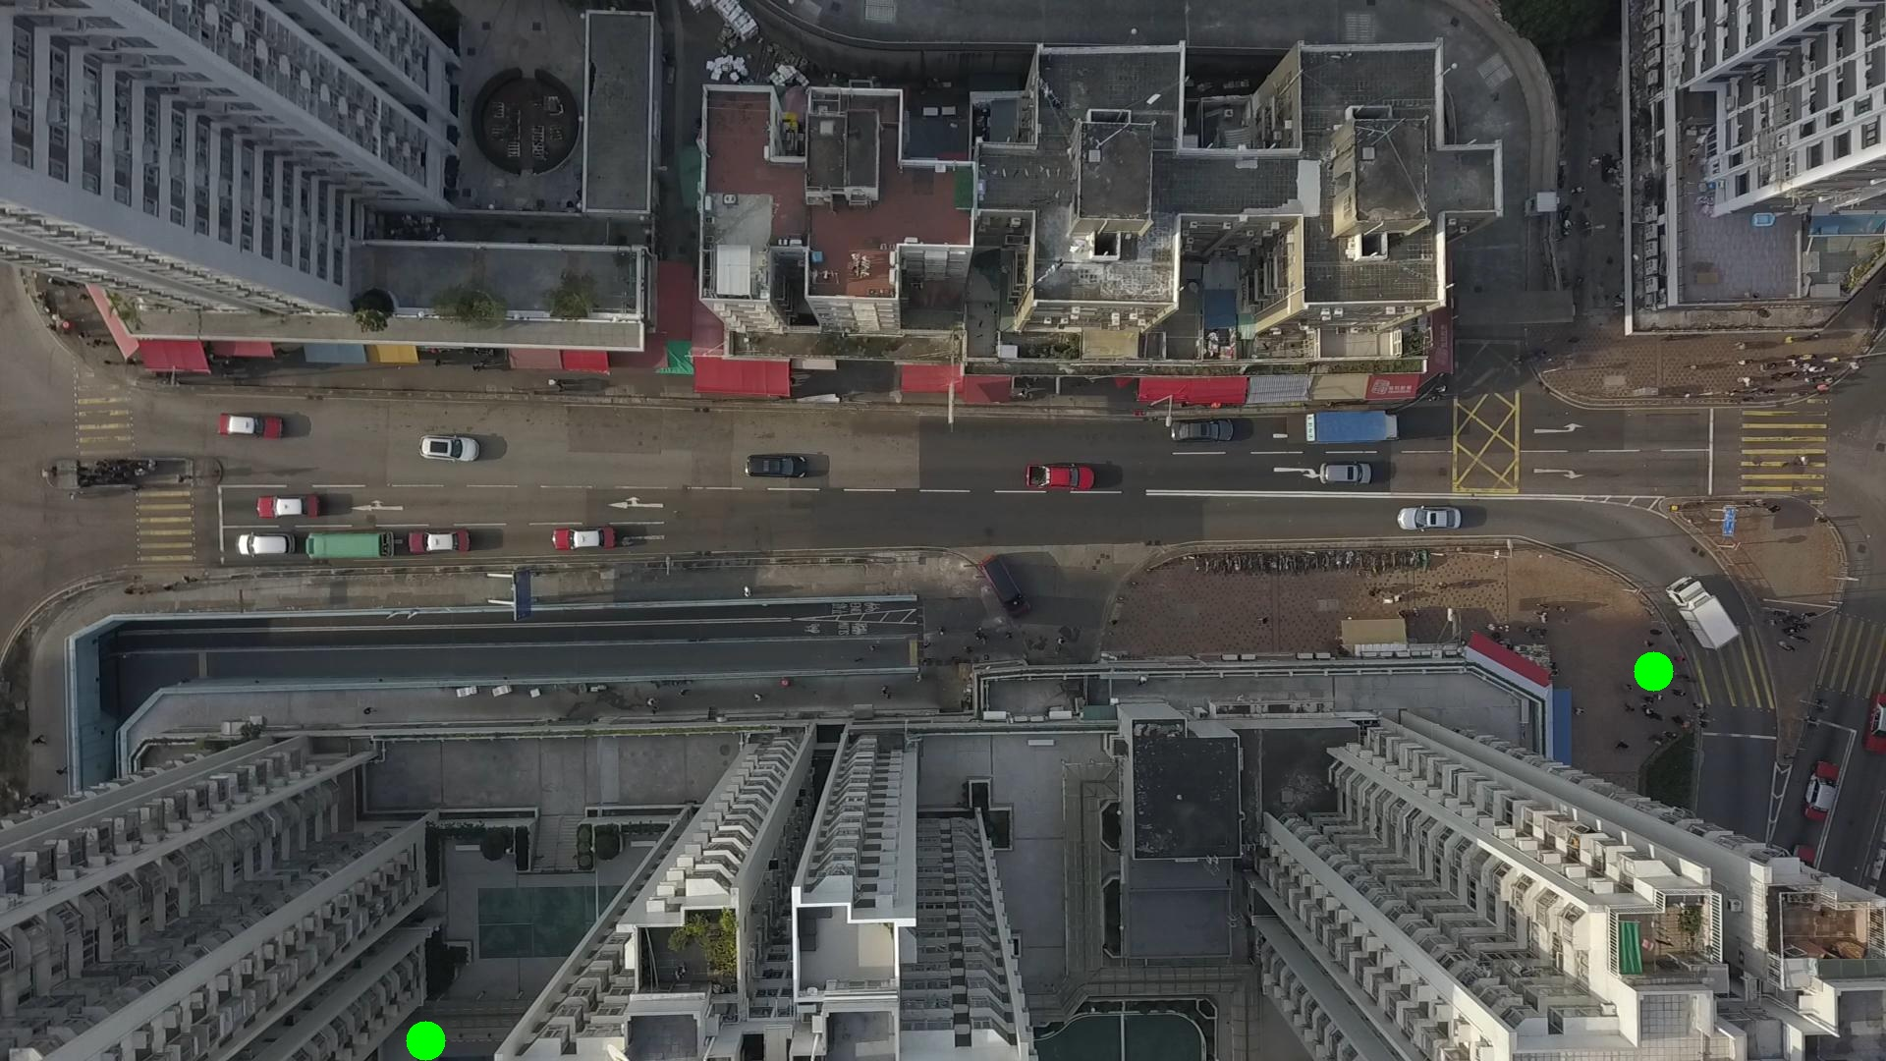

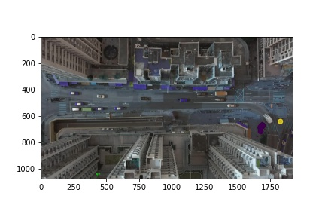

Silhouette metric for img016009.jpg is: 0.9527378112139584

Davies Bouldin metric for img016009.jpg is: 0.07793181587155737

Calinski Harabasz metric for img016009.jpg is: 16057.292529572935

ID 0: (1687, 676)

ID 1: (433, 1059)

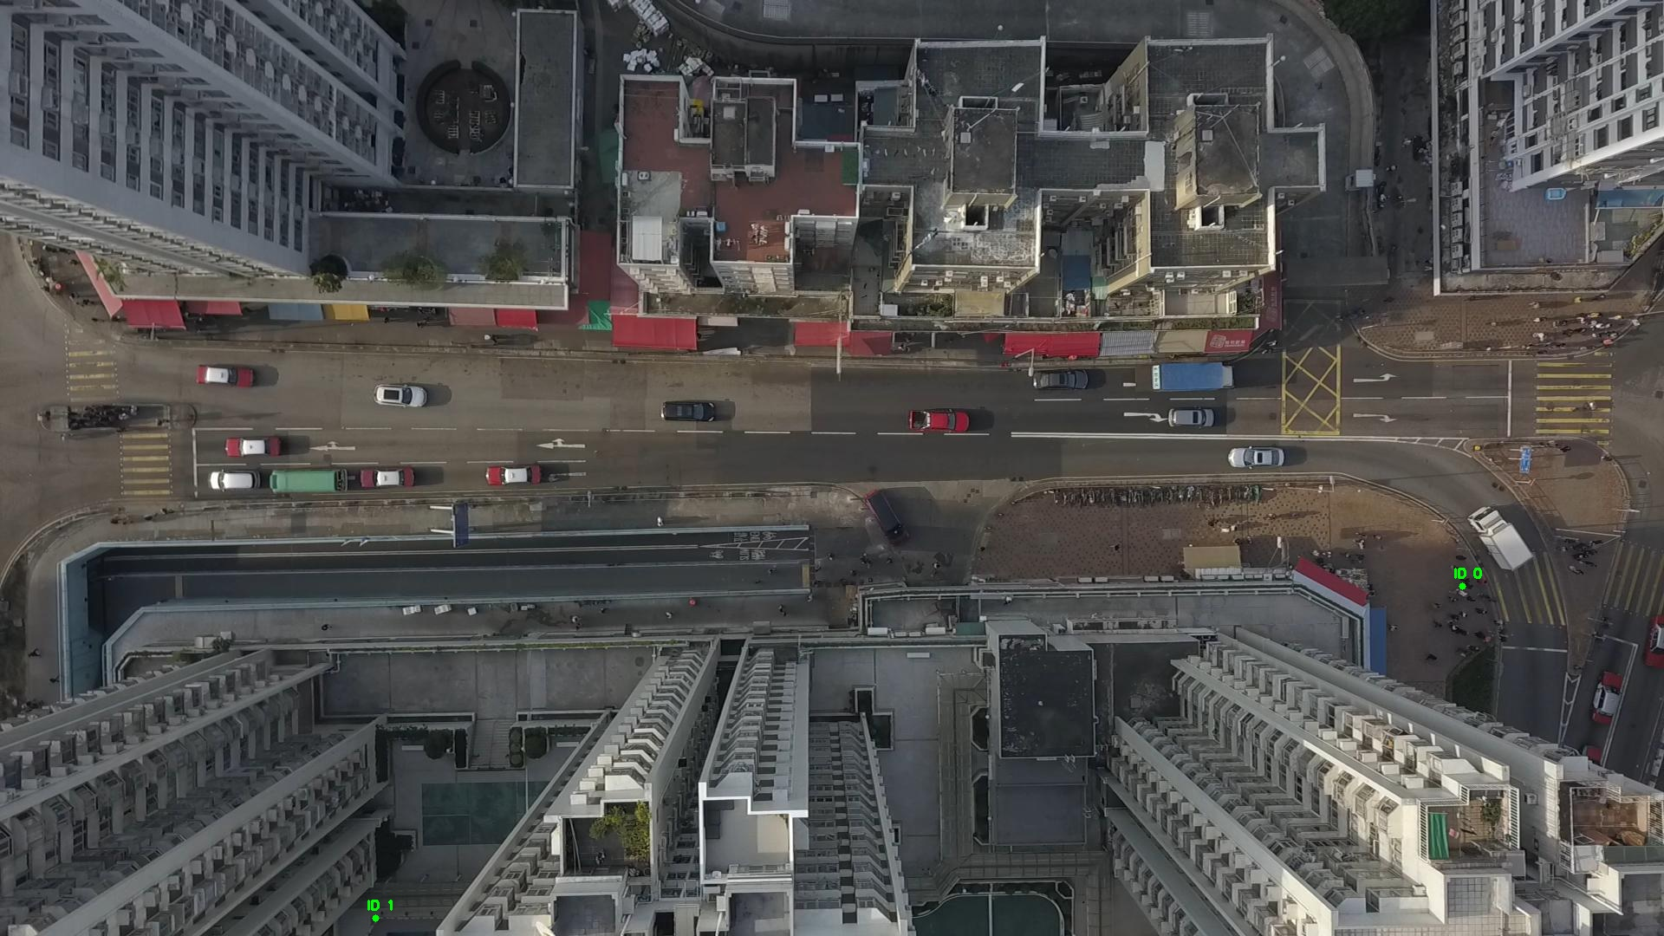

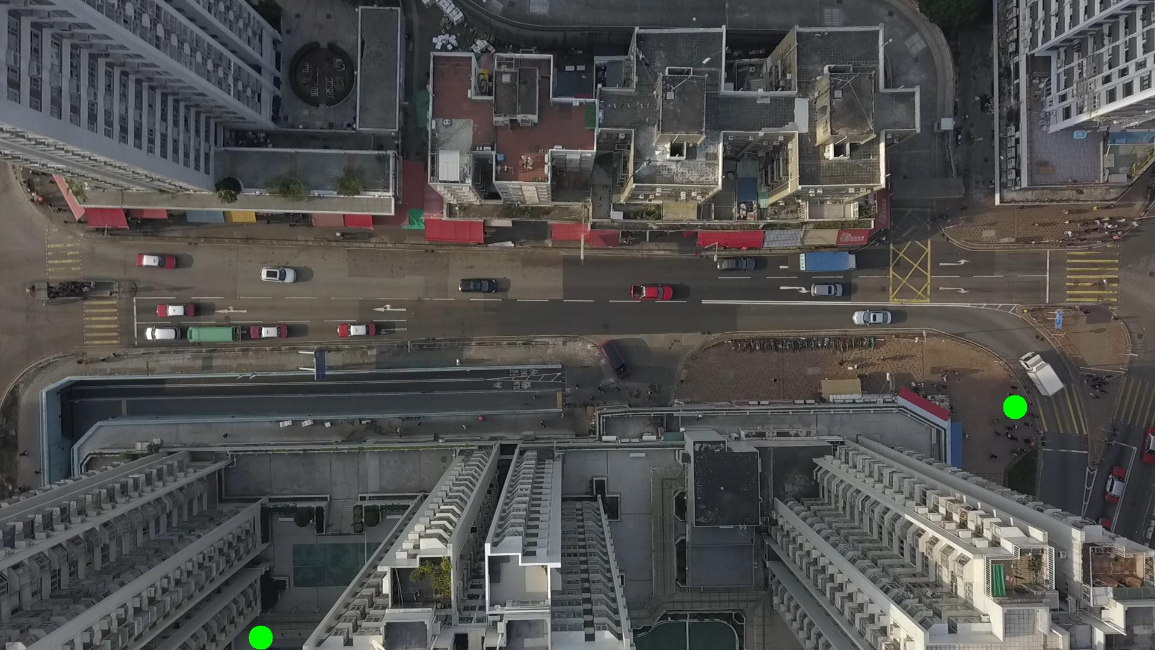

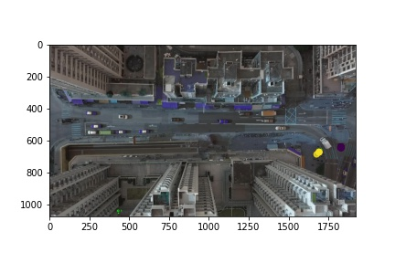

Silhouette metric for img016010.jpg is: 0.9744213227222601

Davies Bouldin metric for img016010.jpg is: 0.03679877010958735

Calinski Harabasz metric for img016010.jpg is: 57287.234373488085

ID 0: (1690, 673)

ID 1: (433, 1059)

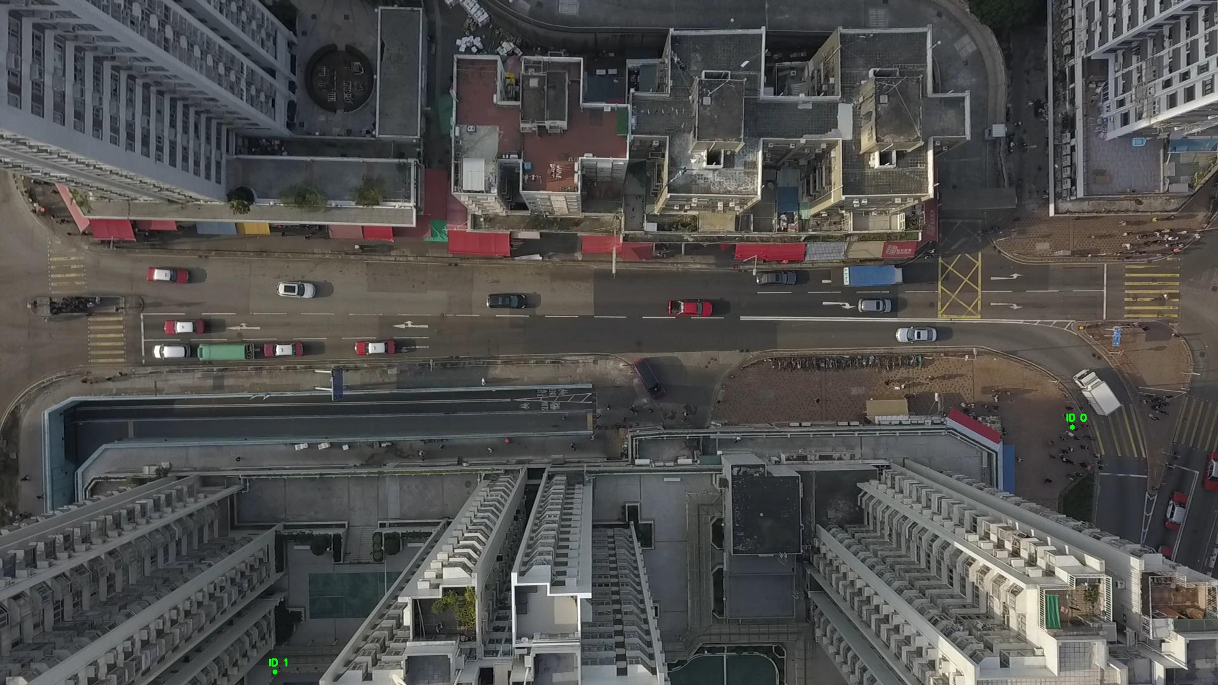

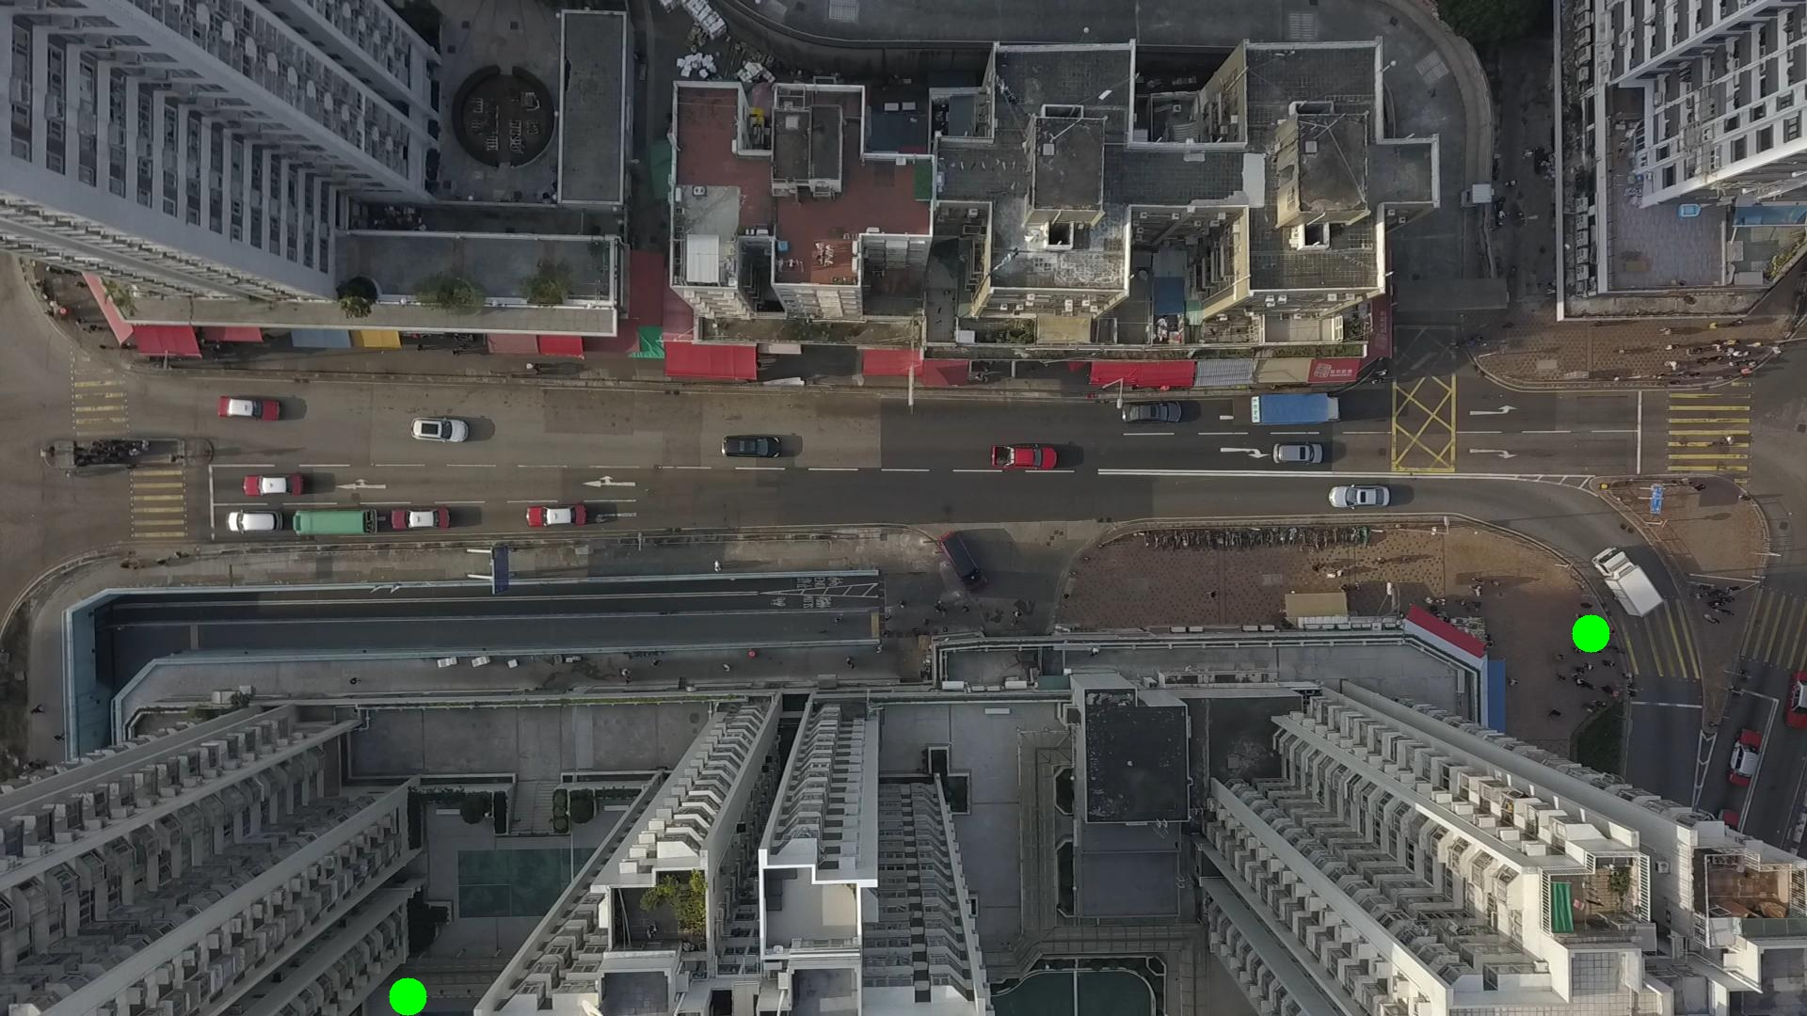

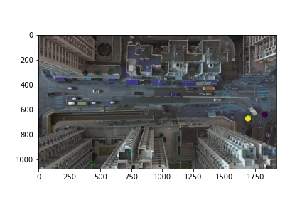

Silhouette metric for img016011.jpg is: 0.974409594301472

Davies Bouldin metric for img016011.jpg is: 0.03607181128634161

Calinski Harabasz metric for img016011.jpg is: 45682.410276473696

ID 0: (1691, 672)

ID 1: (433, 1059)

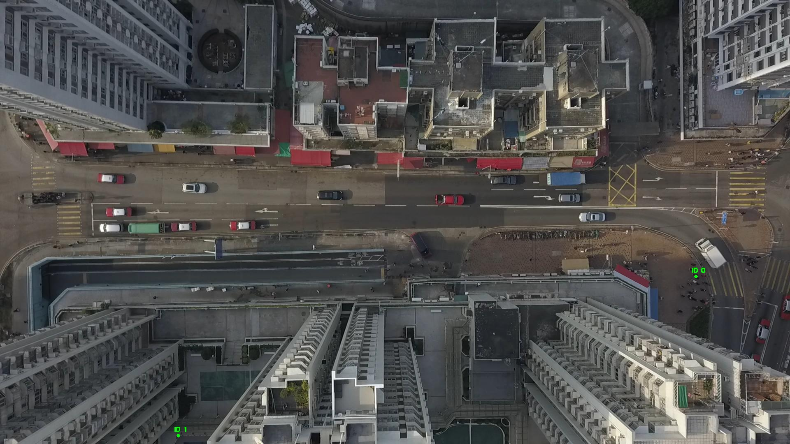

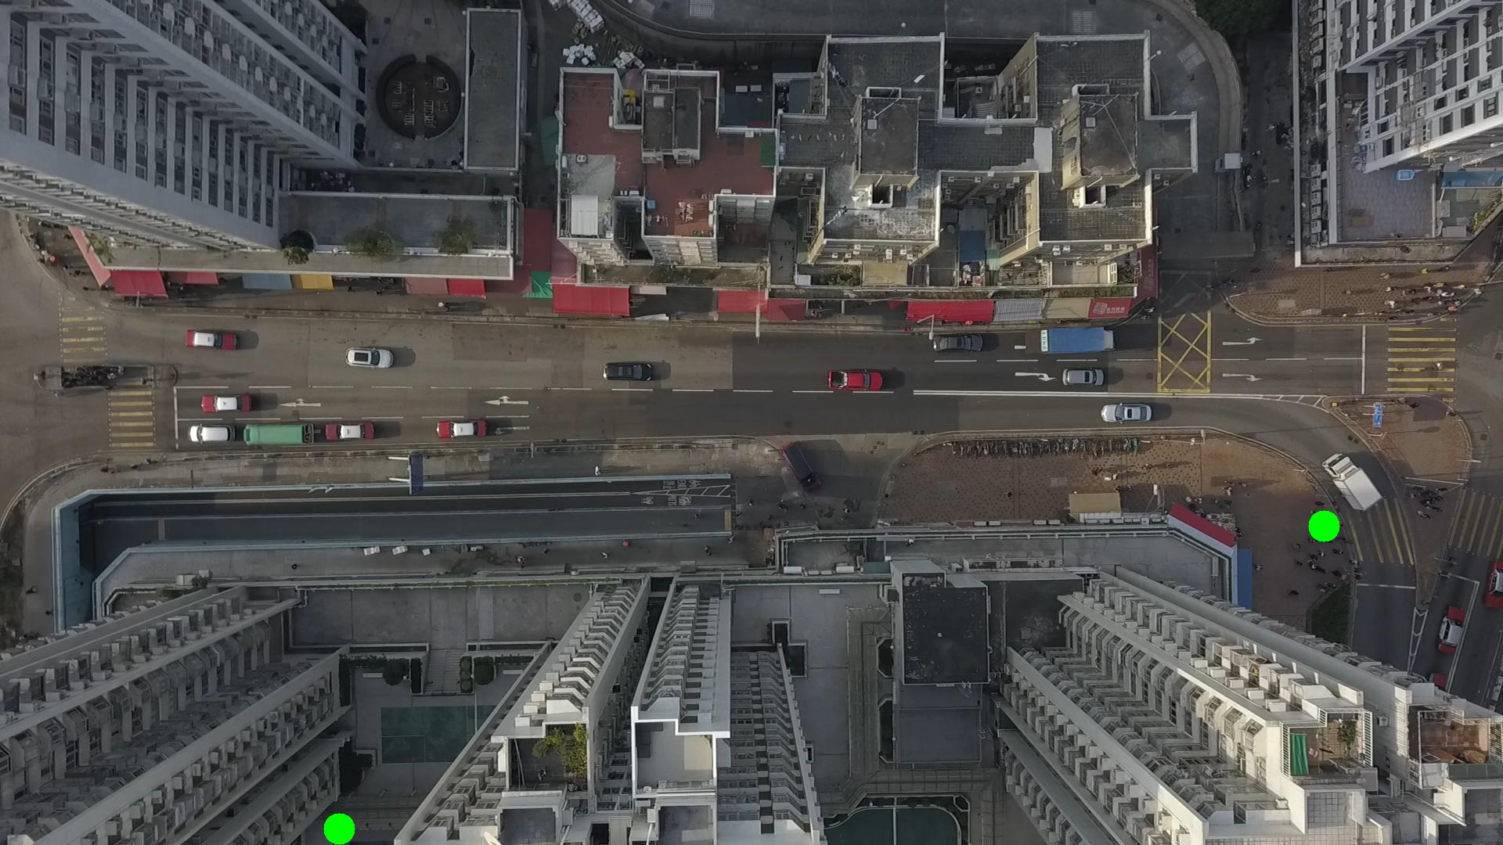

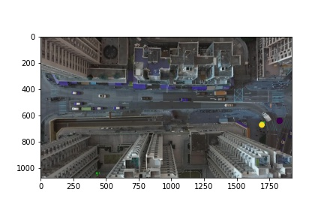

Metrics are not computable for img016012.jpg with bg_tresh: 0.75

ID 0: (1692, 672)

ID 1: (433, 1059)

